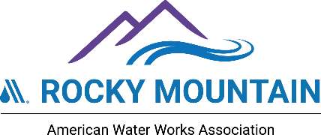

RMSAWWA Sustainable Workforce Committee -- Convening 3.0
You’re Hired! (and what it takes to hear or say these words!)
May 5-6, 2026 – St. Vrain Sanitation District -- Frederick, CO

AGENDA
Day 1 – Tuesday, May 5, 2026

Time | Activities
7:30 to 8:30 | Registration/check in and breakfast
8:30 to 9:00 | Introductions, welcomes, and overview
9:00 to 10:00 | Challenges with recruiting and hiring water sector employees  - Dave Irish – Southgate Water & Sanitation Districts  - Angela Sims-Ceja – Aurora Water  - Chris Kampmann & Heidi Hurtado– St. Vrain Sanitation District  - Sheri Kangas – Distribution Systems Resources
10:00 | Break
10:15 to 11:00 | Facilitated panel discussion (focus on recruiting and hiring)  - Same five people as above (and possibly others)  - Combination of prepared and audience generated questions
11:00 to 11:45 | Best Practices for Talent Recruiting through a Marketing Lens  Lori Jones, Avocet Communications
11:45 to 12:30 | Lunch
12:30 to 2:15 | Presentations by Workforce Pipeline Partners  - Emily Griffith Technical College  - Red Rocks Community College – Skilled Trades Program  - St. Vrain Innovation Center  - Boys and Girls Clubs of Metro Denver  - Carbon Valley Regional Library  - Arapahoe/Douglas County Workforce Center
2:15 to 2:30 | Break – and set up tables for Round Robin
2:30 to 3:30 | Round Robin Networking  - Each Pipeline Partner gets a table -- all participants split up across the six tables; Each session lasts 10 minutes; Everyone visits up to 5 tables
3:30 to 4:00 | Wrap up  - Lessons learned and preview of Day 2  - Team photo  - Adjourn to Networking Event -- Georgia Boys in Frederick.

See Next Page for Day 2
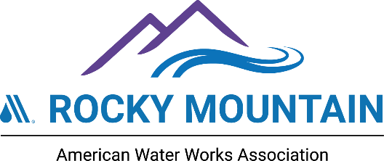

You’re Hired! – RMSAWWA Workforce Convening 3.0 – May 5-6, 2026
Day 2 – Wednesday, May 6, 2026

Time | Activities
7:30 to 8:30 | Registration/check in and breakfast
8:30 to 8:45 | Welcome back – recap – preview/plan for Day 2
8:45 to 9:45 | Focus on Recruiting and Hiring – Success Stories and Lessons Learned  - David Irish, Southgate Water & Sanitation Districts: Revising and repurposing position to facilitate internal recruiting and promotion that resulted in both promotion/career path and improved service delivery.  - Angela Sims-Ceja, Aurora Water: Building and fostering a positive relationship between HR and hiring supervisors, including better job descriptions and better communications.  - Utility HR Professional (to be determined): Lessons learned/do’s and don’ts of interviewing prospective employees.  - Patricia Lopez and Renuka Hiralal, Metro Water Recovery: Strategies and success stories from going out to meet potential candidates at organized career/job fairs.  10-15 minutes of presentation – followed by Q&A for each and the whole group.
9:45 to 10:30 | Panel of recently hired employees – short presentations with facilitated Q&A  - Brand new entry-level operations professional  - Brand new engineer with traditional college education  - Brand new non-technical/operations professional in a customer service, communications, human resources, or finance role  - Experienced operations professional making a career advancement/new role
10:30 to 10:45 | Break
10:45 to 11:30 | Current market trends in the water sector (and others)  Kelsey Klaus -- Arapahoe/Douglas County Work Center
11:30 to 12:15 | Lunch (including team photo)
12:15 to 1:45 | Small Group Work Session – Identification of Opportunities to Support and/or Modify the Existing Work Plan for the RMSAWWA Sustainable Workforce Committee.
1:45 to 2:00 | Break
2:00 to 3:30 | Development and Presentation of Individual Action Plans – identifying items to work on in 1 or 2 weeks, 1 or 2 months, 1 or 2 years
3:30 to 4:00 | Wrap up and close  - Recap of what we did and learned  - Reminder on Sustainable Workforce Committee, RMWC in Keystone  - Team Photo
4:00 | Adjourn to recruit and hire some great people!

